2025-2026 Atatürk Girl Anatolian Imam Preacher High School 7th Grade 2nd Term 2nd Written Exam
Name – Surname: Class: Number:

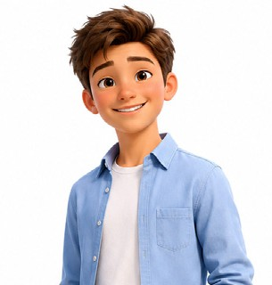
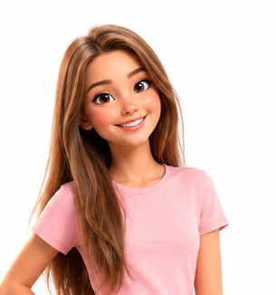
- Read the speech bubbles and write where the people below should go. Use the places in the box. There are two extra places. (E7.8.W1.) (5x5=25)
I want to borrow some books for my English project.
I also need a quiet place to study.
Arda
My little brother is ill. I need to buy some medicine for
him.
Mia
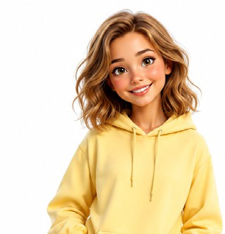
police station - post office - cinema - library - bakery - art gallery - grocery - chemist’s

I found a wallet near the park.
I want to deliver it to the officers.

Selen

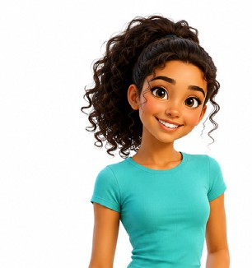
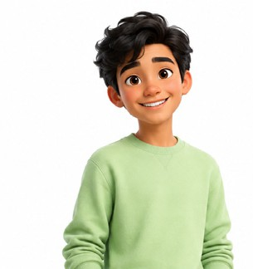
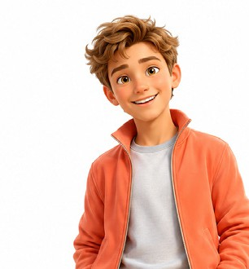
Efe Nina Leo
My mother wants to make sandwiches. I need to buy some fresh bread.
I love paintings.
I want to see new paintings with my friends this
weekend.
I have some pocket money.
I want to watch a funny film after school.

Example: Arda should go to the library.
- ..................................................................................
- ..................................................................................
- .................................................................................
- .................................................................................
- .................................................................................

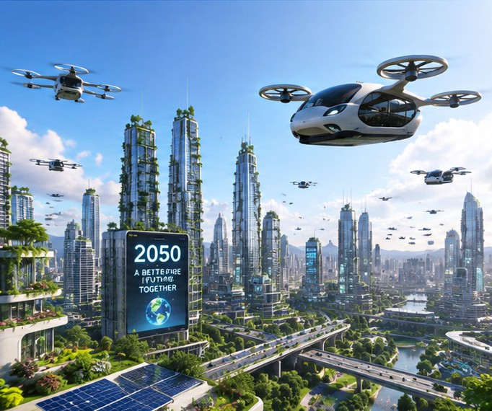
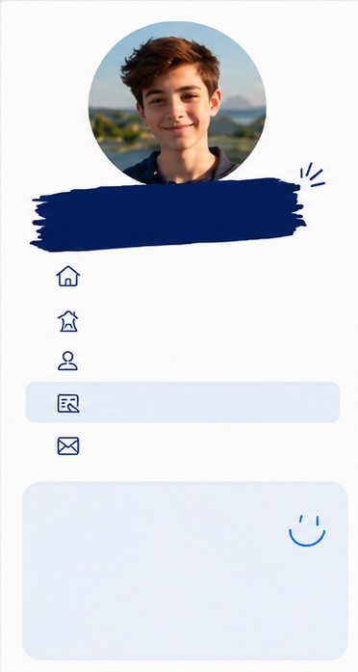
- Read the blog post and answer the questions. (E7.7.R1.) (5x4=20)

Home Blog About Me Details Contact
Philip’s Blog
Hi! I’m Philip. I’m 14 years old and I love technology.
Welcome to my blog! Today, I want to talk about our lives in 2050. I believe the world will be very different. We will probably travel in flying cars, so we won't have any traffic jams in big cities. Technology is developing fast. We will definitely use smart glasses to translate foreign languages instantly. However, I have some worries. If we don't protect the environment, climate change will definitely increase. Many animals will become extinct, and we will probably face water shortages. I hope we will find solutions for these problems. I guess people will use more solar energy to save our beautiful planet. What do you think about our future? Leave a comment below!

- What is Philip’s main interest? .......................................................................................................................................
- What is Philip’s blog post mainly about? ........................................................................................................................
- Why won’t there be traffic jams in big cities in 2050? .....................................................................................................
- What will people use to translate foreign languages? ....................................................................................................
- Why should people use more solar energy? ..................................................................................................................

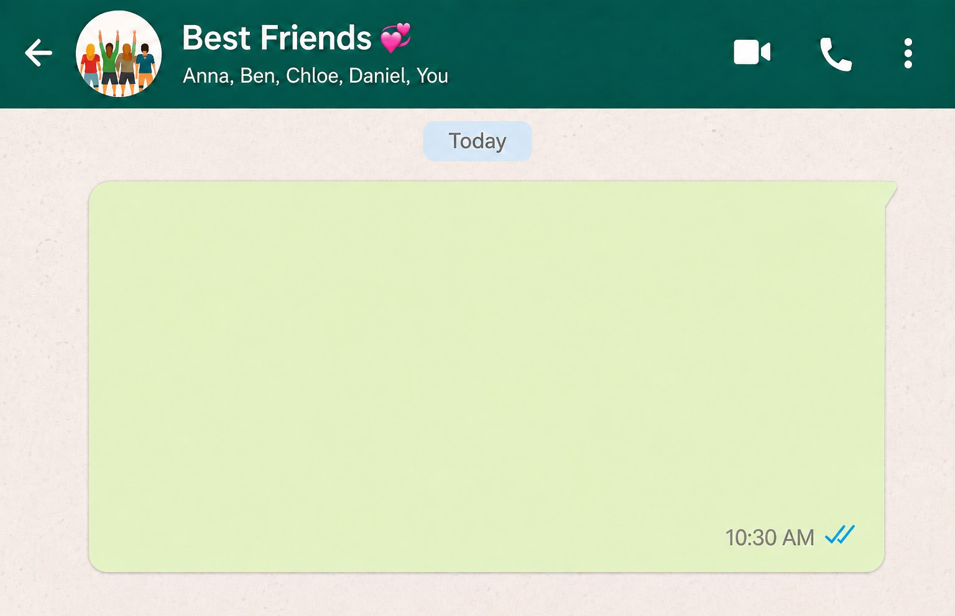
- Read Anna’s message and complete the information card. (E7.6.R1.) (5x3=15)

Hi everyone! Tomorrow is Lily’s birthday. Let’s throw a surprise party for her. First, we need a cake and some candles. Then, we should buy a few balloons and party hats.
Please don’t tell Lily about the party. Come to my house at 5 p.m. and help me decorate the room.

Party for: (1) ........................................
Party type: (2) ......................................
Place: (3) .............................................
Time: (4) ..............................................
One Need: (5) ......................................

- Read Daisy’s talk and write why people go to these places. Write the reasons under the pictures. (E7.8.R1.) (5x4=20)
Hi! I’m Daisy. I live in a quiet neighbourhood near the city centre. There are many places around my house. There is
a bakery next to the supermarket. My mother usually goes there to buy bread in the morning. There is also a small library opposite the park. I go to the library every Friday to borrow story books. My father sometimes goes to the bank to pay the bills. My sister likes the coffee shop near the cinema because she meets her friends there. We don’t have an amusement park in our neighbourhood, but there is a large park. Children go there to ride their bikes.
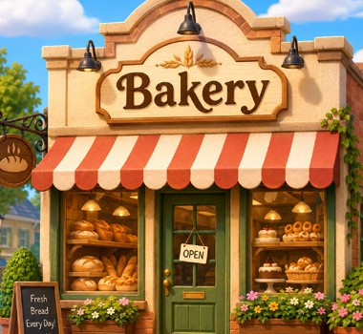
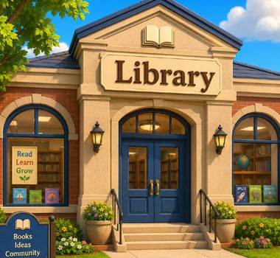

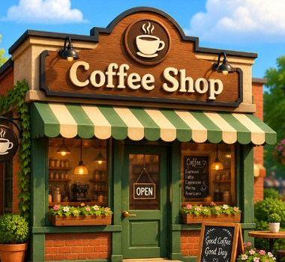
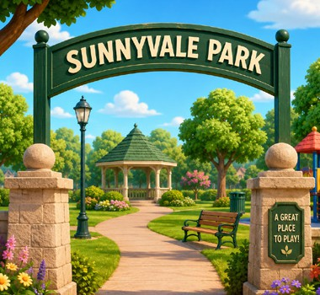

- .............................
.................................
- .............................
.................................
- .............................
.................................
- .............................
.................................
- .............................
.................................

- Read the text and answer the questions. (E7.9.R1.) (5x4=20)
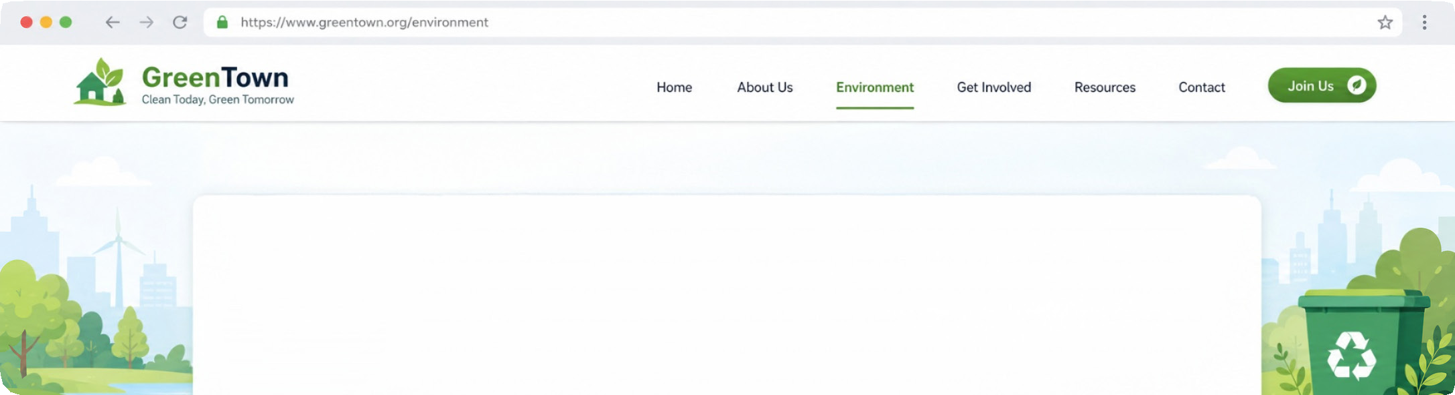
Green Town has serious environmental problems. There is rubbish near the lake, and people throw plastic bottles into the water. This causes water pollution and threatens living creatures. There is also air pollution because many people drive their own cars every day. Some factories do not use filters, so they pollute the air. The town needs urgent solutions. People should use recycling bins. They mustn’t throw rubbish into rivers, lakes or
streets. Factories must use filters. Students can start a clean-up campaign at school. Families should use public transportation or ride bikes. Green Town can be clean again if everyone takes responsibility.

- What environmental problems are there near the lake? ................................................................................................
- Why is there air pollution in Green Town? ......................................................................................................................
- What must factories do to stop polluting the air? ...........................................................................................................
- What should students do to help the town? ...................................................................................................................
- How can families reduce air pollution? ..........................................................................................................................

